**DAY4 JAVA**

**Switch case:**

* Cases have to be the same type as expressions must be a constant or literal
* Duplicate case values are not allowed
* Break is use to terminate the sequence
* If break is not used, it will continue to next case
* Default will execute when none of the above does
* If default is not at the end, put break after it

Syntax:

switch(expression){

case:

statement;

break;

default:

statement;

}

//Print days of week

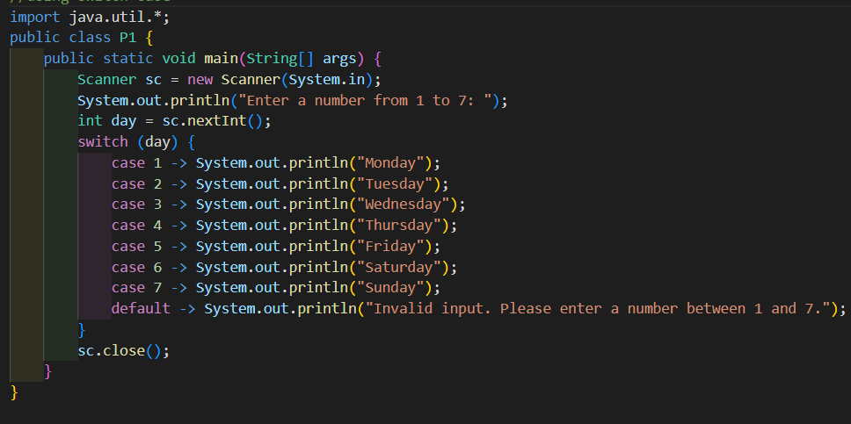

Ternary operator:

Syntax:

(condition)? statement1: statement2;

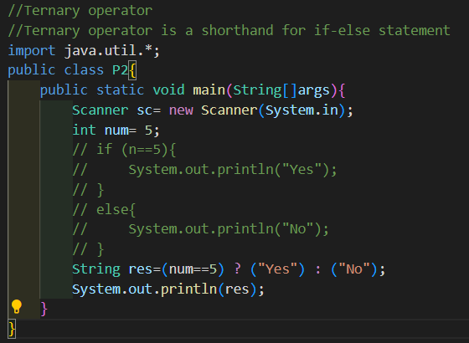

**Digit construction and destruction**

**For-each:**

* In-collections, we don’t have index values
* In those, situations we have to use for-each loop

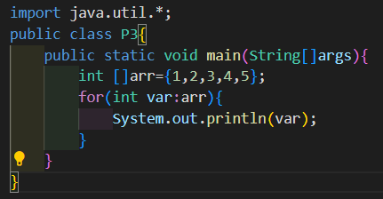

**Recursive Digit sum:**

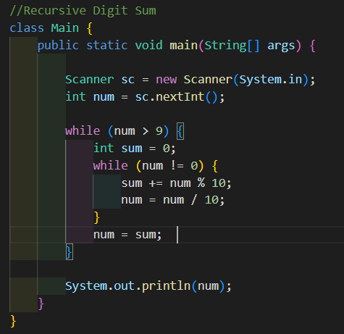

✅ Code Logic in Bullet Points:

* Start with an integer num
* Repeat the following steps while num has more than one digit (i.e., num > 9):
  + Initialize sum = 0 for this round.
  + Loop while num is not 0:
    - Extract the last digit using num % 10.
    - Add it to sum.
    - Remove the last digit from num using integer division (num = num / 10).
  + After summing all digits, update num with this sum to repeat the process if necessary.
* Once num is a single-digit number, print it — this is the digital root.

**Printing Pattern**